|  |
| --- |
| Dissertation Part One Report On |
| **Short Text Emotion Detection Using Multiclass SVM** |
| *A thesis*  *submitted in partial fulfillment of the requirement for the award of the degree of*  **MASTER OF COMPUTER APPLICATIONS**  *In*  **COMPUTER SCIENCE AND ENGINEERING**  *by*   1. **VEERA VENKATA SAI RAJU**   **[Reg. No. 18021F0025]** |
| *Under the Supervision of* |
| **Smt. S.S.S.N USHA DEVI N**  Assistant Professor  CSE, UCEK  JNTUK, Kakinada. |
| *Submitted to*  logo_copy.tif |

**DEPARTMENT OF COMPUTER SCIENCE AND ENGINEERING**

**UNIVERSITY COLLEGE OF ENGINEERING KAKINADA (A) JAWAHARLAL NEHRU TECHNOLOGICAL UNIVERSITY KAKINADA -533003**

**[2018 – 2021]**



**DEPARTMENT OF COMPUTER SCIENCE AND ENGINEERING**

**UNIVERSITY COLLEGE OF ENGINEERING KAKINADA (A) JAWAHARLAL NEHRU TECHNOLOGICAL UNIVERSITY KAKINADA -53300**

**CERTIFICATE**

This is to certify that the thesis entitled **“SHORT TEXT EMOTION DETECTION USING MULTICLASS SVM”** being submitted by **VEERA VENKATA SAI RAJU ATUKURI** bearing the Roll number **18021F0025** in the partial fulfilment for the award of degree of **MASTER OF COMPUTER APPLICATIONS** in **COMPUTER SCIENCE AND ENGINEERING** to UCEK, JNTUK, Kakinada, Andhra Pradesh, India, is a record of bona fide work carried out by him under the guidance and supervision of the Department.

|  |  |
| --- | --- |
| **Project Supervisor**  **Smt. S.S.S.N USHA DEVI N**  Assistant Professor  CSE, UCEK  JNTUK, Kakinada. | **Head of the Department**  **Dr. D. HARITHA**  Professor & HOD CSE, UCEK  JNTUK, Kakinada |

**ACKNOWLEDGEMENT**

I wish to express my sincere gratitude to my project guide **Smt. S.S.S.N USHA DEVI N, UCEK** for providing me with an opportunity to implement my project on “**Short Text Emotion Detection using Multiclass SVM”**. I am grateful for giving me valuable advice and constant source of encouragement throughout the project. Without her valuable inputs and continuous suggestions, this project would not have been possible. Finally, I thank my family and friends for their support.

**Veera Venkata Sai Raju Atukuri**

**TABLE OF CONTENTS**

CHAPTER TITLE PAGE NO.

Abstract5

Chapter 1. INtroduction6

emotion detection6-7

Chapter 2. Literature review8

literature8-11

problem statement11

Chapter 3. prOposed system12

introduction12

architecture13

modules14-15

summary16

rEFERENCES17-18

**Short Text Emotion Detection Using Multiclass SVM**

**Abstract**

Emotions capture the essence of the communication process between people and electronic communication systems. Detecting Emotions such as joy, anger, sadness, fear, and the improves the computer-generated response process for users. Recognizing this type of emotion from a human-made text plays a vital role in applications such as chat conversations, customer support forums, customer reviews, and studying a user's psychology.

Emotion detection is a multi-class classification problem. Here, the sentence may contain the co-occurrence of words related to more than one emotion; hence, classification is challenging. The existing system uses sampling algorithms to deal with multi-class data. However, it affects the time complexity of the system. We found Support Vector Machine (SVM) has a better solution to deal with multi-class data. SVM scales relatively well on multi-class data. We apply the vectorization process to convert text data into numerical feature vectors for training our SVM model. In the proposed system, our objective is to map the short text statement to a specific emotion.

Chapter 1

**INTRODUCTION**

Nowadays humans are interacting the machines because of advancement of technology. They communicating to machines in different formats such as text, audio and video. Predicting the emotion of the user when they communicating to machines, helps them to improve the user experience. Machines will be able to communicate accordingly based on the user emotion. It helps service providers provide tailor-made services to their customers.

Human emotions can be identified by using the text being generated by the user during the communication. Humans exhibits the emotions such as joy, sadness, anger, shame, guilt and fear. Every emotion has some special keywords associated with it. Based on the current frame of mind of a user, he uses certain keywords, these keywords help us to predict the user emotion. humans use these words to express their emotions. Emotions and their associated keyword are mapped by finding the underlying relations between them.

* 1. EMOTION DETECTION

Emotion detection (ED) is a branch of sentiment analysis that deals with the extraction and analysis of emotions. These emotion lexicons contain emotion search words or keywords such as happy, hate, angry, sad, surprise, and so on. The task is to find occurrences of these search words in a written text at the sentence level. Once the keyword is identified within the sentence, a label is assigned to the sentence.

For instance, if the constructed emotion dictionary contains joy and the written text from which emotion is to be determined reads “I was filled with so much joy on seeing my mother for the first time in five years,” the sentence is emotionally labelled with the keyword joy. This approach though simple and straightforward faces challenges, including the need for an emotion dictionary to contain reasonable number of emotion categories, since limited keywords can greatly affect the performance of the approach among ambiguity of keywords and the lack of linguistic information.

For Emotion Detection from a machine learning model different parameter should be taken into consideration. Various types of techniques are used to detect emotions from a human being like facial expressions, body movements, blood pressure, heart beat and textual information.

This project focuses on the emotion detection from textual information. Emotion Detection in text documents is essentially a content - based classification problem involving concepts from the domains of Natural Language Processing as well as Machine Learning. In this paper emotion recognition based on textual data and the techniques used in emotion detection are discussed.

In this project proposes emotion detection in short texts using multiclass SVM. It detects the seven emotions joy, Sadness, guilt, shame, fear, anger, disgust.

Chapter 2

**LITERATURE REVIEW**

2.1 LITERATURE

Youg-Jun Lee, Chan-Yong Park and Ho-Jin Choi in the paper “**Word-Level Emotion Embedding based on Semi-Supervised Learning for Emotional Classification in Dialogue**” [1] discussed emotion classification in dialogue based on semi-supervised word-level embedding. They used the NRC Emotion Lexicon which is list of English words and their associations with eight basic emotions. They added word-level emotion vectors to obtain utterance-level emotion vectors.

Shadi Shaheen, Wassim El-Hajj, Hazem Hajj and Shady Elbassuoni in the paper “**Emotion Recognition from Text Based on Automatically Generated Rules**” [2] proposed a framework that can recognize the emotions present in the communication or the emotions of the involved user to improve the user experience. In this work they considered syntactic and semantic structure of sentence and then generalized it by representation using wordNet and ConceptNet, which will create an emotion recognition rule (ERR).

Haji Biali, Chen Wu and Vidyasagar Potdar in the paper “**Computational Approaches for Emotion Detection in Text**” [3] discussed various emotion detection theories that provide a basics for emotion models. It shows how those models have been used in computational approaches to emotion detection. They used the SVM algorithm for validating the proposed architecture.

Dr. Sattar B. Sadkdhan and Ahmed Dheyaa Radhi in the paper “**Fuzzy Logic used in Textual Emotion Detection**” [4] discussed how the fuzzy logic can be used to detect emotion subjects from textual data. In this project, fuzzy logic was to convert the non-value member to value member. They developed a system using fuzzy logic and sentiment analysis to classify emotions represented in text.

Maruf Hassan, Mb. Sakib Bin Alam and Tanveer Ahsan in the paper “**Emotion Detection from Text using Skip-through Vectors**” [5] discussed a way of finding emotion from text by using the lexical approaches and machine learning techniques. In their work they used deep learning model named skip-thought, an approach to learning fixed length representations of sentences, to face the problem of emotion detection from text. In this project they showed skip-thought vectors were well suited for emotion detection task.

Khodijah Hulliyah, Normi Sham Awag Abu Bakar and Amelia Riathani Ismail in the project “**Emotion Recognition and Brain Mapping for Sentiment Analysis: A Review**” [6] discussed the computational linguistic areas that are interested in the attention of emotion for Sentiment Analysis. Sentiment Analysis observes the emotion conveyed by a text, and at same time, distinguishing positive and negative valence. This paper provides the overview of past and recent research on emotion detection as well as some approaches and techniques used and shows the linked between both Sentiment Analysis and Emotion Recognition.

Harpreet Kaur, Veenu Mangat and Nidhi in the project “**A Survey of Sentiment Analysis Techniques**” [7] discussed about emotion extraction using text mining. How to find the polarity of the text and classify in into positive, negative or neutral. It helps in human decision making. This paper presents the survey of main approaches used for sentiment classification.

Sophia Yat Mei Lee and Zhongqing Wang in the paper “**Multi-view Learning for Emotion Detection in Code-switching Texts**” [8] they emphasised on analyzing emotions in monolingual text, neglecting the fact that emotions are aften found in bilingual or code-switching posts in social media. They used a multi-view learning framework to learn and detect the emotions through both monolingual and bilingual views. In this project, the monolingual views are extracted from the monolingual text separately, and the bilingual view is constructed with both monolingual and translated text collectively. Empirical studies demonstrate the effectiveness of their proposed approach in detecting emotions in codeswitching texts.

Zhije Liu, Xueqiang Lv, Kum Liu and Shuicai Shi in the paper “**Study on SVM Compared with the other Text Classification Methods**” [9] discusses the applications of Support Vector Machine in text categorization. They introduced the basic principle of SVM and described the process of text classification. They showed SVM-based classification model was effective for text classification using machine learning.

A. Mathur and G. M. Foody in the paper “**Multiclass and Binary SVM Classification: Implications for Training and Classification Users**” [10] discussed how binary SVM can be extended for a one-shot multiclass classification needing a single optimization operation. In this project one-shot multiclass classification of multispectral data was more accurate than the approaches based on a series of binary class classification.

Muljono, Nurul Anisa Sri Winarshi and Catur Supriyanto in the paper “**Evaluation of Classification Methods for Indonesian Text Emotion Detection”** [11] evaluates the performance of four different classification methods: Naïve Bayes, J48, K-Nearest Neighbor and Support Vector Machine-Sequential Minimum Optimization. In this project they used Indonesian text corpus, containing 1000 sentences which consists of six emotions. They concluded that SVM-SMO classifier gives the best performance.

Tapasy Rabeya, Sanjida Ferdous, Himel Suhita Ali and Narayan Ranjan Chakraborty in the paper “**A Survey on Emotion Detection: A Lexicon Based Backtracking Approach for Detection form Bengali Text**” [12] discussed how emotions are detected from different textual data. In this project In case of lexicon-based analysis, the position of emotional lexicons really varies the state of an emotion. They presented an emotion detection model to extract emotions from Bengali text, considered two basic emotions happiness and sadness. This lexicon based backtracking approach has been introduced for recognizing the sentiments of a sentence to show how frequently people express their emotions in the last part of a sentence. Their proposed method produced a result with 77.16 accuracies.

Fika Hastarita Rachaman, Riyanatarto Sarno and Chastine Fatichah in the paper “**CBE : Corpus Based of Emotion Detection in Text Detection**” [13] discussed about forming automatic emotional corpus-Based of Emotion(CBE). CBE developed from Wordnet Affect Emotion and Affective Norms for English Words with term similarity measure and distance of node approach. Latent Dirichlet Allocation (LDA) is used too for automatically expand CBE. CBE attributes are a score of Valence (V), Arousal (A), Dominance (D) and categorical label emotion. Categorical label emotion based on six basic emotions of Ekman.

Zhaorang Zong and Changhun Hong is the paper “**On Application of Natural Language Processing in Machine Translation**” [14] discussed the natural language processing of statistical corpora with neural machine translation and concludes the natural language processing: Neural Machine translation has the advantage of deep learning, which is very suitable for dealing with the high dimension, dimension, label-free and big data of natural language, therefore, its application is more general and reflects the power of big data and big data thinking.

Feng Tian and Husian Zhang, Longzhuang Li, Qinghua Zheng and Yang Yang in the paper “**Visualizing e-Learner Emotion, Topic, and Group Structure In Chinese Interactive Texts**” discussed how e-learner’s emotion combined with topics and group structure. For achieving this goal, they used a colour palette of emotions based on plutchiks’s colour palette was presented, an extended cascaded PLSI algorithm using sliding window technique was proposed to detect and track topics in Chinese interactive texts, and multiple star-field variants were introduced to display the group structure.

2.4 PROBLEM STATEMENT

Emotion detection from short text is multiclassification problem. Using the labelled corpus generate co-occurrence of words and convert the dataset into word embeddings. Support Vector Machine (SVM) scales relatively well on multi-class data. Build the model using the SVM and train the model with vectorized dataset. Predict the emotion embedded in the short texts.

Chapter 3

**PROPOSED SYSTEM**

* 1. INTRODUCTION

Predicting the human emotion based on the text is a multiclass problem, because the machine learning model has to map every word to their corresponding emotions. Mapping the words to the emotions is difficult. The text might contain unwanted words such as stop words, different words but with the same meaning and same words with different context. It is challenging for a model form a word dictionary for every emotion.

Proposed system uses the Support Vector Machine (SVM) classifier to predict the emotion involved in a short text message. We found SVM has a better solution to deal with multi-class data. Support Vector Machine (SVM) scales relatively well on multi-class data.

Before training the model, data must be brought into a form that is predictable and analyzable for training the model. So, pre-processing the dataset is required. It helps in building the more accurate model and improves the model performance.

After preprocessing the text, we convert the text into numerical form by using word embedding techniques. Every line of text in the corpus is converted into a numerical vector. First the text is converted into a dictionary and word count format using the counter container and then counter objects are converted into numerical vectors by using the word embeddings. Dictvectorizer is used in this project to convert the counter objects into the numerical vectors. We train the SVM models with numerical data.

* 1. ARCHITECTURE

Training Phase

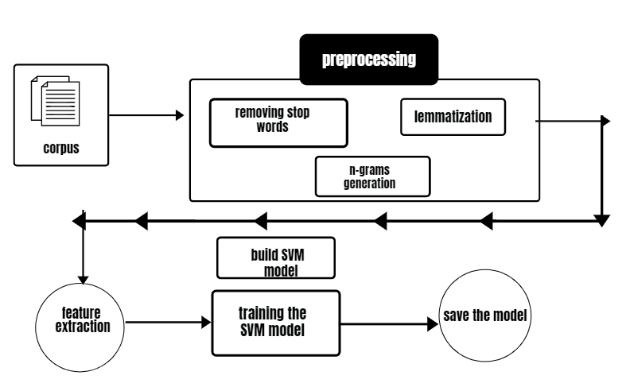

Testing Phase

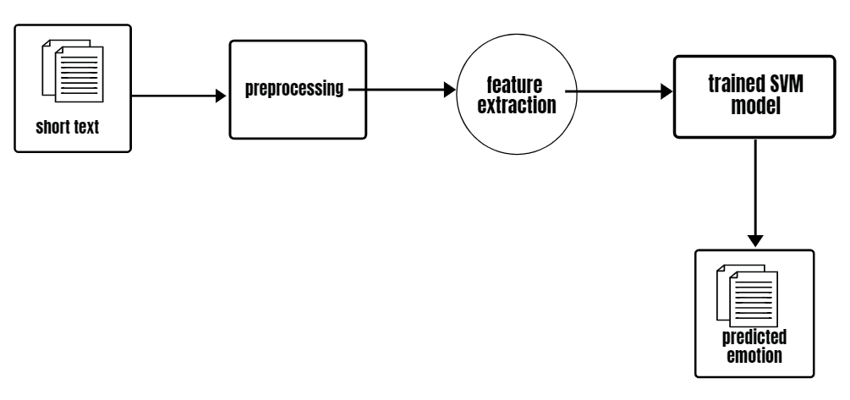

3.3 MODULES

This project is divided into four modules.

1. Preprocessing
2. Feature Extraction
3. Building Model
4. Model Evaluation

* PREPROCESSING

Preprocessing is a stage where the data is brought into a form which used for training the model. predictable and analyzable for training the model. So, pre-processing the dataset is required. It helps in building the more accurate model and improves the model performance.

Text pre-processing is performed in the following procedure

* Converting the text into lower case letters
* Removing the stopwords.
* Removing the special character from the text [!@#$%^.......].
* Lemmatizing the text.
* N-grams generation [co-occurring words].
* FEATURE EXTRACTION

Machine learning algorithms cannot work with raw text directly, the text must be converted into numerical vectors. Converting the text data into numerical form is called feature extraction or feature encoding. Feature extraction is used extract and produce feature representations that are appropriate for the type of Natural Language Processing (NLP) task we are trying to accomplish and the type of model you are planning to use.

To train the model data must be in the numerical form. Since, our corpus is in the text form we need to convert the text into a numerical. This project converts the text in the corpus to numerical form using the following techniques

* Bag of Words

It is a way of representing text in the feature extraction phase. It is used to develop a bag-of-words model for collection of documents and helps to use different techniques to prepare a vocabulary and score words. In this project we convert each line of text in the dataset into container objects. Each container object stores the text data in dictionary format. Key is the word and value is the count of occurrence of the corresponding word in a given text.

* Vectorization

These container objects are still not in the trainable format. So, these objects are converted to numerical vectors using the vectorization technique where each vector represent emotional text in the corpus.

Now, the dataset is in the required format to train the model.

* BUILDING MODEL

Machine learning model is built by training the model with dataset. During the training process the machine learning model finds the underlying relationships in the dataset and acquires the expertise to make the prediction on the data it has never seen.

The model must be trained with the adequate amount of data, otherwise it results in the model underfitting or overfitting and it affects the accuracy of the model. We must perform the preprocessing on the data to ensure the quality in the dataset.

Before training the model, we must split the dataset for testing and training. In this project dataset is split into 80:20, 80% of dataset is used for training the model and 20% dataset is used for evaluating the model. The samples in the dataset are shuffled prior to splitting the dataset.

To build the model, we create an SVM model by using the predefined packages in the sklearn module. Read the dataset and split into two parts. And then we start training the model with training dataset.

* MODEL EVALUATION

Model Evaluation is an integral part of the model development process. It helps to find the best model that predicts accurately on the unseen samples. In this project 20% of the dataset is used to evaluate the model performance.

In this project after training the SVM model, the model performance is measured by using accuracy.

Accuracy **=** Correct Predictions **/** Total Predictions

Accuracy is defined as the percentage of correct predictions for the test data. It can be calculated easily by dividing the number of correct predictions by the number of total predictions.

* SUMMARY

In this Project dataset is preprocessed for improving the performance of the model. It generates the co-occurrence of words using n-grams technique and text is converted into vectors by using word embeddings. Dataset divided into two parts for training and testing. We build a Multiclass SVM model and we train the model using training dataset. Performance of the model is evaluated by using the testing dataset. This model predicts the seven emotions for short texts, they are joy, sadness, shame, guild, anger, disgust, fear.

REFERENCES

[1] Eric Cambria, Andrew Livingstone and Amir Hussain. The Hourglass of Emotions. Cognitive Behavioural Systems 2011, LNC 7403, pp. 144-157, 2012.

[2] Jianhui Pang, Yanghui Rao. Fast Supervised Topic Model for Short Text Emotion Detection.

2168-2267, 2019

[3] S. Bao et al., “Mining social emotions from affective text,” IEEE Trans. Knowl. Data Eng., vol. 24, no. 9, pp. 1658–1670, Sep. 2012.

[4] Y. Rao, J. Lei, W. Liu, Q. Li, and M. Chen, “Building emotional dictionary for sentiment analysis of online news,” World Wide Web, vol. 17, no. 4, pp. 723–742, 2014.

[5] Y. Song, H. Wang, Z. Wang, H. Li, and W. Chen, “Short text conceptualization using a probabilistic knowledgebase,” in Proc. 22nd Int. Joint Conf. Artif. Intell., 2011, pp. 2330–2336.

[6] C. Huang, L. S. Davis, and J. R. G. Townshend, “An assessment of support vector machines for land cover classification,” Int. J. Remote Sens., vol. 23, no. 4, pp. 725–749, Feb. 2002.

[7] C.-W. Hsu and C.-J. Lin, “A comparison of methods for multiclass support vector machines,” IEEE Trans. Neural Netw., vol. 13, no. 2, pp. 415–425, Mar. 2002.

[8]H. Lee, Y. S. Choi, S. Lee, and I. Park, “Towards unobtrusive emotion recognition for affective social communication,” in Consumer Communications and Networking Conference (CCNC), 2012 IEEE. IEEE, 2012, pp. 260–264.

[9] M. Bouazizi and T. Ohtsuki, “Sentiment analysis: From binary to multiclass classification: A pattern-based approach for multi-class sentiment analysis in twitter,” in Communications (ICC), 2016 IEEE International Conference on. IEEE, 2016, pp. 1–6.

[10] S. M. Mohammad and P. D. Turney, “Crowdsourcing a word-emotion association lexicon,” vol. 29, no. 3, pp. 436–465, 2013.

[11] S.-Y. Chen, C.-C. Hsu, C.-C. Kuo, L.-W. Ku et al., “Emotion lines: An emotion corpus of multi-party conversations,” arXiv preprint arXiv:1802.08379, 2018

[12] T. Mikolov, K. Chen, G. Corrado, and J. Dean, “Efficient estimation of word representations in vector space,” arXiv preprint arXiv:1301.3781, 2013.

[13] E. C.-C. Kao, C.-C. Liu, T.-H. Yang, C.-T. Hsieh, and V.-W. Soo, “Towards text-based emotion detection a survey and possible improvements,” in Information Management and Engineering, 2009. ICIME’09. International Conference on. IEEE, 2009, pp. 70–74.

[14] and Possible Improvements." Information Management andEngineering, 2009. ICIME'09. International Conference on. IEEE,

2009.

[15] Esuli, Andrea, and Fabrizio Sebastiani. "Sentiwordnet: A publicly available lexical resource for opinion mining." Proceedings of LREC. Vol. 6. 2006

[16] T-Y Kwok. Automatic Text Categorization Using Support VectorMachine[C]. Proc. Int. Conf. on Neural Information Processing, 1998. 347-351.

[17] Jichao Chen. Technology and Application of Support Vector Machine[J](in chinese). Science & Technology Information (Science teaching and research), 2007, (25):490-491

[18] Changchun Cui, Wenlin Liu, Junzhe Zheng. Theory and application of support vector machine[J] (in Chinese ). Journal of Shenyang Institute of Engineering (Natural Science),2007,3(02):170-172.